**Project Report: Simple Calculator Using HTML, CSS, and JavaScript**

**1. Introduction**

This project involves creating a simple calculator application using HTML for structure, CSS for styling, and JavaScript for functionality. The calculator can perform basic arithmetic operations such as addition, subtraction, multiplication, and division.

**2. Objectives**

* To understand the basics of web development using HTML, CSS, and JavaScript.
* To create a functional user interface for the calculator.
* To implement arithmetic operations using JavaScript.

**3. Tools and Technologies**

* **HTML**: For creating the layout of the calculator.
* **CSS**: For styling the calculator and making it visually appealing.
* **JavaScript**: For implementing the calculator's functionality and handling user input.

**4. Project Structure**

* **index.html**: The main file containing the HTML structure.
* **styles.css**: The file responsible for the styling of the calculator.
* **script.js**: The JavaScript file that contains the logic for performing calculations.

**5. Implementation**

**5.1 HTML (cal.html)**

The HTML file contains a simple structure with buttons for digits (0-9), operations (+, -, *, /), a display area, and an "equals" button.

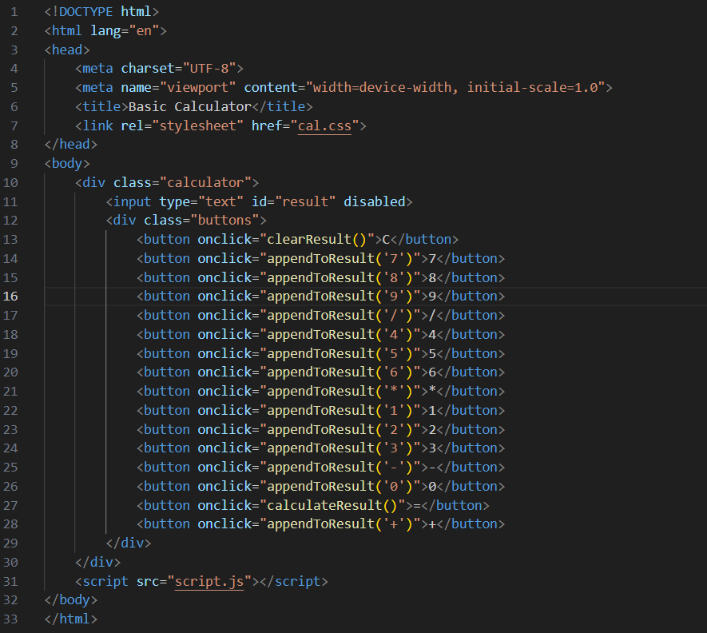

**5.2 CSS (styles.css)**

The CSS file styles the calculator for a clean and user-friendly appearance.

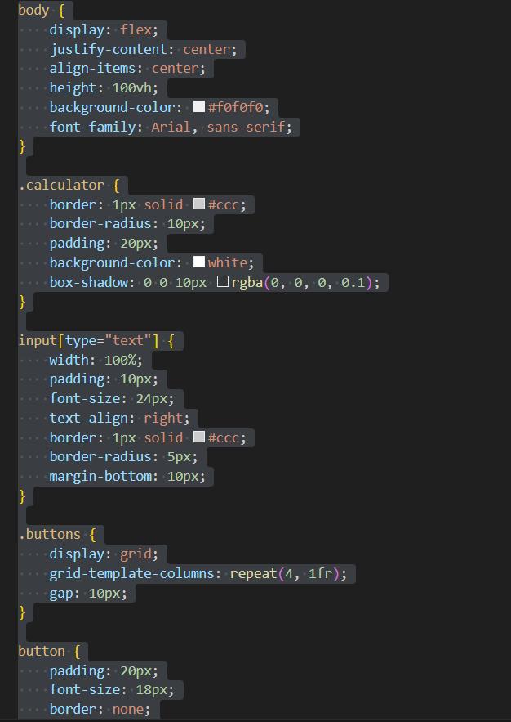

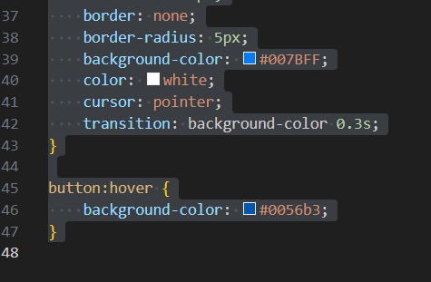

**5.3 JavaScript (script.js)**

The JavaScript file handles the logic of the calculator, including displaying numbers, performing calculations, and clearing the display.

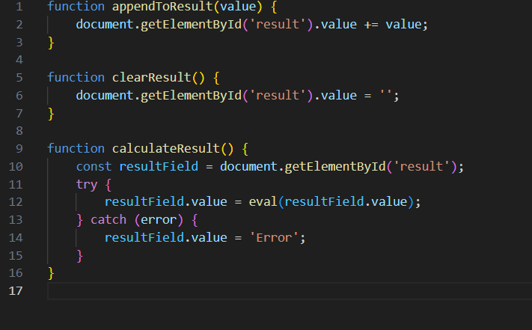

**6. Testing**

The calculator was tested by performing various arithmetic operations and ensuring that all buttons functioned correctly. Edge cases, such as dividing by zero and entering invalid expressions, were also tested to ensure the application handles errors gracefully.

**7. Conclusion**

The project successfully demonstrated how to create a simple web-based calculator using HTML, CSS, and JavaScript. It provided practical experience in web development and a better understanding of client-side scripting.

**8. Future Improvements**

* Enhance the calculator with additional functions like square root, exponentiation, and memory functions.
* Implement a more sophisticated error handling mechanism.
* Improve the user interface with animations and a more responsive design.

This project serves as a foundational exercise in web development and can be expanded upon for more complex applications in the future.

Anmol Kumar

2200290100027